Field Trips

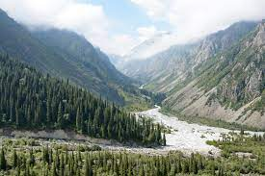
Tour 1. National Natural Park Ala-Archa
Day 1 | 18.08.23 | - Departure to Bishkek.  - On the way visiting historic Burana Tower and Historical and Archaeological Museum.  - Arrival in Bishkek: hotel accommodation and city tour  Meal: lunch and dinner
Day2 | 19.08.23 | - Departure to the Ala-Archa Gorge  - Climbing to the waterfall  - Arrival in Bishkek  Meals: breakfast, lunch, dinner

Tour 2. Son-Kul Lake
Day1 | 18.08.23 | - Departure from Chok -Tal village to Son-Kul lake  - Accommodation at the yurt camp  - Horse riding (optional)  Meal: lunch and dinner
Day2 | 19.08.23 | - Departure to Bishkek through the pass "32 parrots”  - Visit to the waterfall  - En route visit historic Burana Tower and Historical & Archeological Museum  - Arrival in Bishkek  Meal: breakfast, lunch, dinner
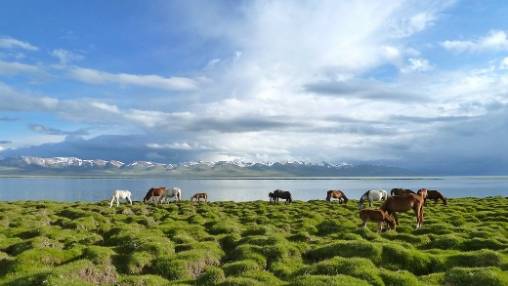

Tour 3. Chon-Kyzyl-Suu Gorge
Day1 | 18.08.23 | - Departure from Chok-Tal village to Grigorievskoye and Semenovskoye Gorges  - Arrival in Karakol: city tour, visiting Przewalski Museum, Dungan Mosque, Church  - Overnight stay in Karakol guest house  Meals: lunch and dinner
Day2 | 19.08.23 | - Departure to Zheti-Oguz Gorge  - Chon-Kyzyl-Suu Gorge: visit the Hydrometeorological station of RCEECA  - Departure to Karakol city (or to a guesthouse for overnight stay)  Meals: breakfast, lunch, dinner
Day3 | 20.08.23 | - Departure from Karakol along the southern shore  - Drive to Barskoon Gorge (3 waterfalls)  - Visit to Skazka (Fairy Tale) Canyon  - Departure to Bishkek  Meals: breakfast, lunch, dinner

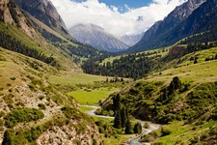

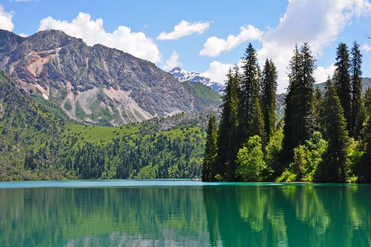
Tour 4. Sary-Chelek Lake
Day1 | 18.08.23 | - Departure from Chok Tal village to Bishkek  - En route visit historic Burana Tower and Historical and Archeological Museum  - Arrival in Bishkek, check-in at hotel: Cititur  Meal: lunch and dinner
Day2 | 19.08.23 | - Departure from Bishkek  - Arrival in Arkyt village, overnight stay  Meals: breakfast, lunch, dinner
Day3 | 20.08.23 | - Ascent to Sary-Chelek Lake  - Departure to Bishkek  Meals: breakfast, lunch, dinner

